Azure Segmented Service Deployment, teacher dry run guide

Goal
Build the deployment once, validate each traffic path, and capture the proof as you go.
The target policy is still:
- Internet to server on TCP 80: Allow
- Internet to server on TCP 22: Deny
- Internet to server on TCP 8080: Deny
- Client VM to server on TCP 80, 22, 8080: Allow

Recommended design
Use this exact shape:
- 1 resource group
- 1 virtual network
- 2 subnets
  - server-subnet
  - client-subnet
- 1 server VM in server-subnet
- 1 client VM in client-subnet
- 1 NSG attached to server-subnet only for the first pass
Why two subnets? Because “segmented” should mean something, not just sound fancy at a faculty meeting.
Also, keep the NSG on the subnet only for the dry run. Microsoft’s guidance says that if an NSG is on both the subnet and the NIC, inbound traffic is processed at the subnet and then the NIC, and the traffic must be allowed by both. That is a fine troubleshooting lesson later, but a bad starting point for a clean build. (Microsoft Learn)

Step 1. Create the resource group and virtual network
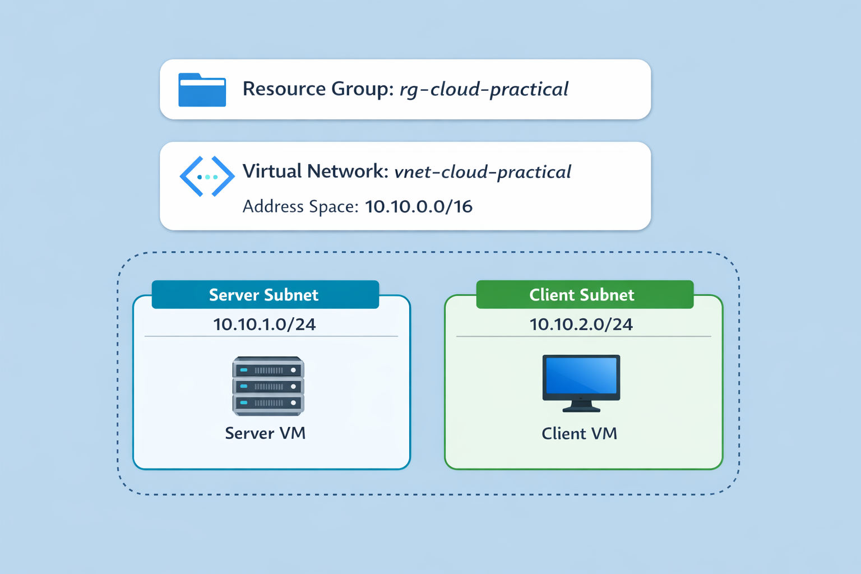
Create:
- Resource group: rg-cloud-practical
- VNet: vnet-cloud-practical
- Address space: 10.10.0.0/16
- server-subnet: 10.10.1.0/24
- client-subnet: 10.10.2.0/24

Validate
- Both subnets exist
- The server and client will land in different subnets

Capture
- Screenshot: resource group overview after the VNet and subnets exist

Step 2. Create the NSG and rules
Create an NSG named nsg-server-segment.
Attach it to server-subnet.
Create these inbound rules in this order:
- 100 Allow-Client-HTTP
  - Source: 10.10.2.0/24
  - Protocol: TCP
  - Destination port: 80
  - Action: Allow
- 110 Allow-Client-SSH
  - Source: 10.10.2.0/24
  - Protocol: TCP
  - Destination port: 22
  - Action: Allow
- 120 Allow-Client-8080
  - Source: 10.10.2.0/24
  - Protocol: TCP
  - Destination port: 8080
  - Action: Allow
- 130 Allow-Internet-HTTP
  - Source: Internet
  - Protocol: TCP
  - Destination port: 80
  - Action: Allow
- 140 Deny-Internet-SSH
  - Source: Internet
  - Protocol: TCP
  - Destination port: 22
  - Action: Deny
- 150 Deny-Internet-8080
  - Source: Internet
  - Protocol: TCP
  - Destination port: 8080
  - Action: Deny
- 160 Deny-VNet-Other
  - Source: VirtualNetwork
  - Protocol: Any
  - Destination port: *
  - Action: Deny
That last rule matters. Azure NSGs include a default inbound rule called AllowVNetInBound at priority 65000, which allows VirtualNetwork to VirtualNetwork traffic unless you override it with a higher-priority custom rule. Rules are processed from lower number to higher number, and once traffic matches a rule, evaluation stops. (Microsoft Learn)

Validate
- Your client allow rules are above the deny rules
- Deny-VNet-Other is above the default 65000 rules
- Port 80 is allowed from both the client subnet and the internet
- Ports 22 and 8080 are allowed only from the client subnet

Capture
- Screenshot: NSG inbound rules page

Step 3. Create the server VM
Create the server VM in server-subnet.
Use:
- Ubuntu LTS
- Public IP: yes
- Public inbound ports during creation: none, if possible
You want the NSG to do the filtering. Wizard-created “help” has the same vibe as a cable box from 2007.

Validate
- The VM is in server-subnet
- It has a public IP
- There is no surprise NIC-level NSG unless you put it there on purpose

Capture
- Screenshot: server VM overview showing VM name and public IP

Step 4. Create the client VM
Create the client VM in client-subnet.
For the teacher dry run, give it a public IP so you can SSH into it from your own machine. This is practical. You are validating the lab, not trying to win a purity contest.

Validate
- The VM is in client-subnet
- You can SSH into the client VM from outside Azure

Capture
- Screenshot: client VM overview

Step 5. Install Nginx on the server
SSH to the server VM and run:
sudo apt update
sudo apt install -y nginx
sudo systemctl enable --now nginx
systemctl status nginx --no-pager

Create the page:
cat <<'EOF' | sudo tee /var/www/html/index.html >/dev/null
<!doctype html>
<html lang="en">
<head>
<meta charset="utf-8">
<title>Azure Segmented Service Deployment</title>
<style>
body { font-family: Arial, sans-serif; max-width: 800px; margin: 40px auto; line-height: 1.6; }
h1 { color: #1a4f8b; }
.box { padding: 16px; background: #f4f7fb; border-left: 4px solid #1a4f8b; }
</style>
</head>
<body>
<h1>Azure Segmented Service Deployment</h1>
<p>This site is the public-facing prototype for the practical exam.</p>
<div class="box">
<h2>What this demonstrates</h2>
<p>Port 80 is public. SSH and the internal service are restricted by NSG policy.</p>
</div>
</body>
</html>
EOF

Validate
- systemctl status nginx shows active
- curl http://localhost returns your page

Capture
- Screenshot: terminal showing Nginx running
- Optional screenshot: curl http://localhost

Step 6. Start the internal-only service on port 8080
On the server:
mkdir -p ~/internal-site
cat <<'EOF' > ~/internal-site/index.html
<h1>Internal-only service</h1>
<p>If you can read this from the client VM, the policy works.</p>
EOF

nohup python3 -m http.server 8080 --directory ~/internal-site > ~/http8080.log 2>&1 &
ss -ltnp | grep 8080
curl http://localhost:8080

Validate
- Port 8080 is listening
- Local curl to http://localhost:8080 works

Capture
- Screenshot: terminal showing the listener on 8080
- Screenshot: terminal showing the local curl result

Step 7. Prove the public website works
From your own machine, outside Azure:
Open:
http://SERVER_PUBLIC_IP

Validate
- The page loads from the public IP
- It is your page, not the default Nginx page

Capture
- Screenshot: browser showing the page on port 80

Step 8. Prove public SSH fails
From your own machine, outside Azure:
ssh -o ConnectTimeout=5 youruser@SERVER_PUBLIC_IP

Or:
nc -vz -w 5 SERVER_PUBLIC_IP 22

Validate
- The connection attempt fails from a non-client source

Capture
- Screenshot: failed SSH or nc test
- Optional short video if the timeout is awkward and you want live evidence

Step 9. Prove Azure says the deny is real
Use NSG diagnostics or IP flow verify in Network Watcher.
Microsoft’s current docs say:
- NSG diagnostics simulates a flow and returns whether it is allowed or denied, with the rule that allowed or denied it
- IP flow verify checks whether a packet is allowed or denied to or from an IP, and tells you which rule matched (Microsoft Learn)

Option A, NSG diagnostics
Use:
- Target: server VM
- Direction: Inbound
- Protocol: TCP
- Source: your public IP or Internet
- Destination port: 22

Option B, IP flow verify
Use:
- VM: server VM
- Direction: Inbound
- Protocol: TCP
- Local port: 22
- Remote IP: your public IP

Validate
- Result says Denied
- The result names the matching deny rule

Capture
- Screenshot: the diagnostic result and rule name

Step 10. SSH from client VM to server VM
From your local machine, SSH to the client VM. Then from the client VM, SSH to the server private IP.
ssh youruser@CLIENT_PUBLIC_IP
ssh youruser@SERVER_PRIVATE_IP

Validate
- SSH works from the client VM to the server VM
- You used the server private IP, not the public IP

Capture
- Screenshot: terminal showing successful SSH from client to server

Step 11. Reach the internal-only service from the client VM
From the client VM:
curl http://SERVER_PRIVATE_IP:8080

Optional:
nc -vz SERVER_PRIVATE_IP 8080

Validate
- The internal-only page loads from the client VM

Capture
- Screenshot: terminal showing successful curl to port 8080

Step 12. Optional extra sanity check
From your own machine, outside Azure:
curl --max-time 5 http://SERVER_PUBLIC_IP:8080

Validate
- It fails publicly

Capture
- Optional screenshot for your own records

Step 13. Cleanup
Delete the resource group after you finish validating and capturing evidence.
Also keep this note in your final handout: do not use NSG flow logs for this practical. Microsoft says new NSG flow logs can no longer be created after June 30, 2025, and NSG flow logs retire on September 30, 2027. Use NSG diagnostics or IP flow verify instead. (Microsoft Learn)

Capture
- Optional screenshot: resource group delete confirmation

Capture checklist, in order
Take these as you go:
- Resource group overview
- Server VM overview with public IP
- Client VM overview
- NSG inbound rules
- Server terminal showing Nginx running
- Server terminal showing port 8080 service running
- Browser showing public page on port 80
- Failed public SSH attempt
- NSG diagnostics or IP flow verify showing Denied and the rule name
- Client VM successful SSH to server private IP
- Client VM successful curl to server private IP on port 8080

Two things most likely to bite you
- Accidentally relying on Azure’s default VNet allow rule
That is why Deny-VNet-Other is in the guide. Without it, your “client-only” logic may still work, but for the wrong reason. (Microsoft Learn)
- Testing the wrong address
Use:
- public IP for internet tests
- private IP for client-to-server tests

Verdict
Yes, this is the version to follow and validate.
The important corrections are:
- use two subnets
- attach one NSG to the server subnet
- add Deny-VNet-Other
- use NSG diagnostics or IP flow verify for the deny proof
Everything else is plumbing and screenshots.

